Friday 13th June 2025

Dear Parents and Carers


I would like to just begin, this week, by thanking you all for your patience and understanding around the commencement of our roof project. As you will have seen, the scaffolders are working their way around the school, in preparation for the main works to start on the roof as soon as we break up for the summer holiday.
The impact of running a school, around such a large building project is going to be challenging and I am very quickly getting use to the fact that plans and deadlines change daily! As much as possible, I will try to give you advanced notice of any works that will impact you or your child’s class, without overloading you with too much information at once.

With that said, the next area of scaffolding to go up will be along the school building, in the car park, on Monday 16th June. This means the single Year 3 gate and the double car park gates will be out of use for a couple of days, early next week. However, I have spoken to Little Jimmy’s Nursery, and they are happy for us to use their gates to get onto the school grounds, from Constable Avenue. All the other gates will still be in use (apart from the double gate at the front of the school, which is now the builders’ compound).
After this area is complete, the scaffolders will be moving to outside the Year 1 and Year 2 classrooms from Tuesday 17th June for a few days. I will let you know alternative arrangements for drop off and collection times, if you have a child in these year groups, next week.
Finally (for now) the scaffolding outside the Year 3 classrooms should be complete by home time on Monday. You will just need to drop your child off at the library doors again, in the morning.

`Well done to Y1, Y2 and Y4
A huge well done to Years 1, 2 and 4 who have been undertaking National assessments this week. Year 1 and some of the Year 2 children have completed their phonics screening checks and Year 4 did their multiplication tables check. Feedback from their teachers has been so positive, saying that they are so proud of how the children approached these checks, that they were amazing and that they had ‘smashed it’. The children and teachers have put so much effort into preparing for these checks and we want to thank you for helping them prepare at home too.

Learning

Last week we marked World Environment Day with lots of learning around climate change and plastic pollution.

We had a lovely email following this from Archie Watson in 1B. His Mum said that “he has always had interest in helping the environment but since world environment day even more so. He wants to let you know that we joined a volunteer litter picking group and received bags and litter pickers and did our second pick today of this week. His little sister joined in this time too.”
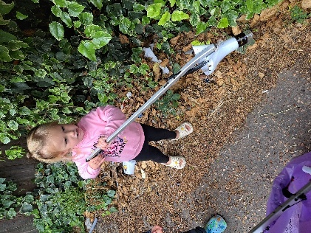
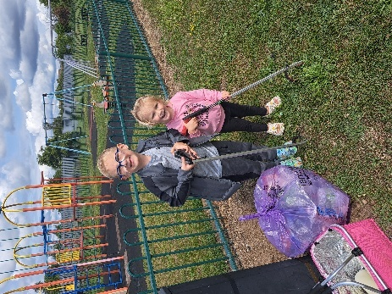
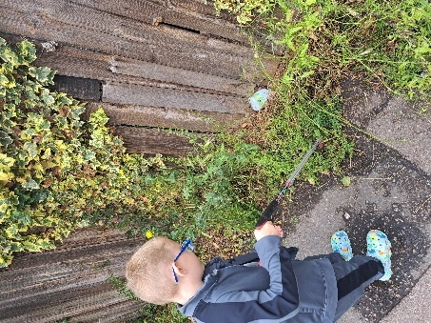
How lovely to see that Archie has been inspired by his learning and has continued this at home. What a great job you are all doing!

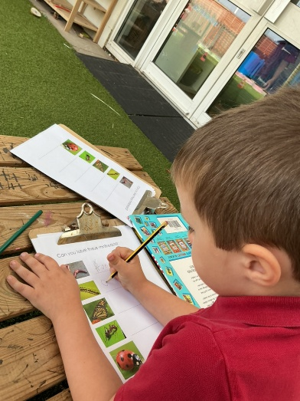
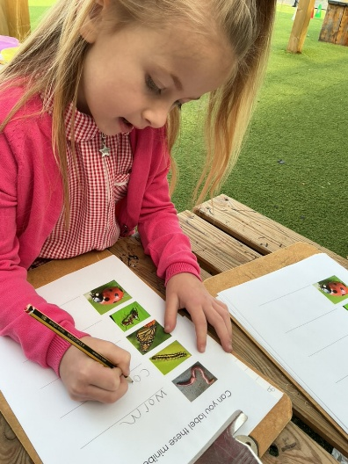
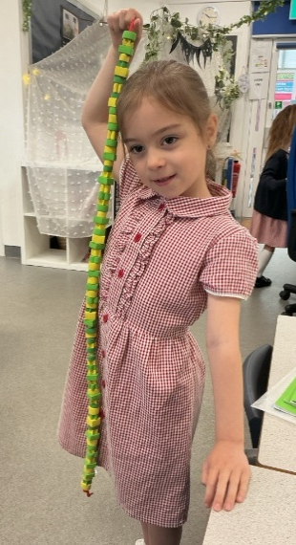
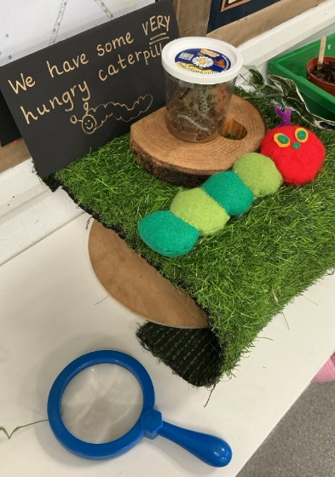
The Reception children had a special delivery this week… Some very hungry caterpillars! We have been watching them eat lots and grow very quickly. The children have been practising their writing skills by labelling minibeasts and creating AB patterns when threading to look like a caterpillar.

The children in year 2 have been learning the difference between volume and capacity and learning to read how many ml are in each container.
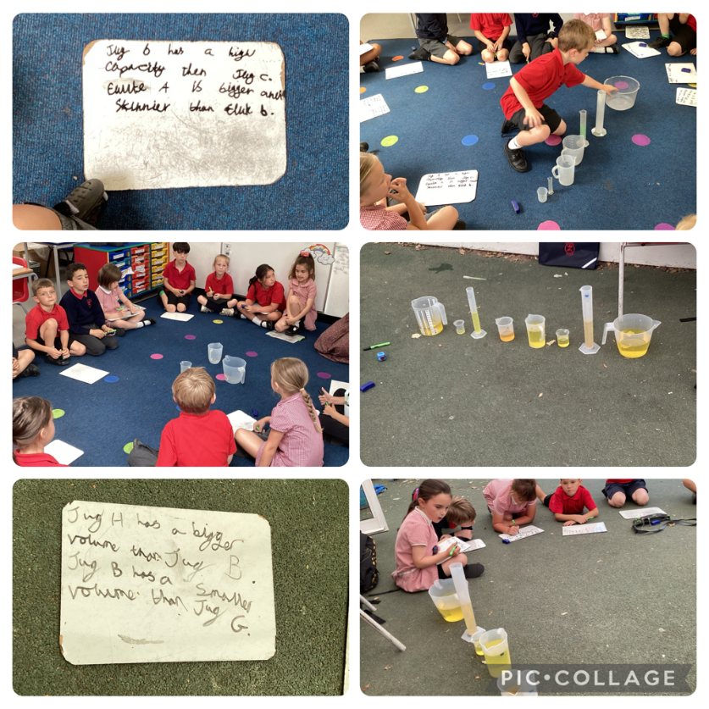

In P.E. this half term, Year 4 have been working on communication, collaboration, teamwork and resilience. This week, each group had to stand on a bench and then work together to get change the order, e.g. by getting into order by our first names, height etc. but without touching the floor. If anyone stepped off the bench, we had to go back to our start positions!! The children found some different ways to move around on the benches, showing good problem solving skills.
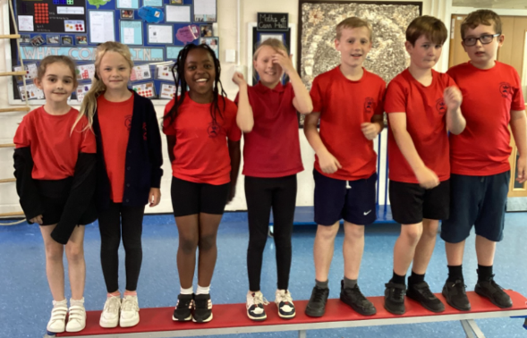
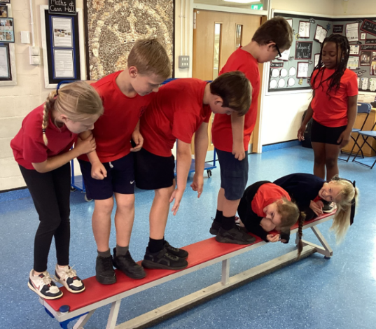
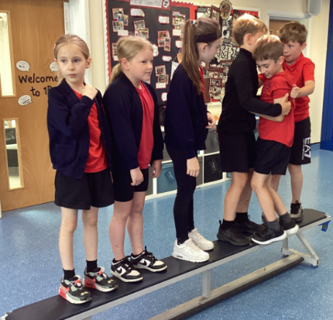
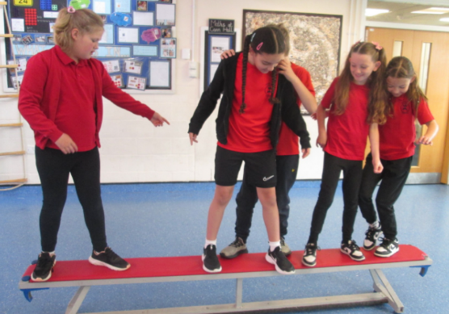
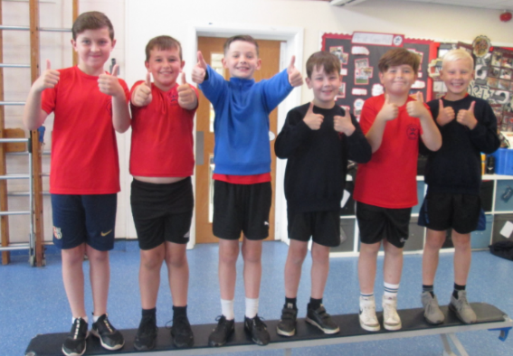
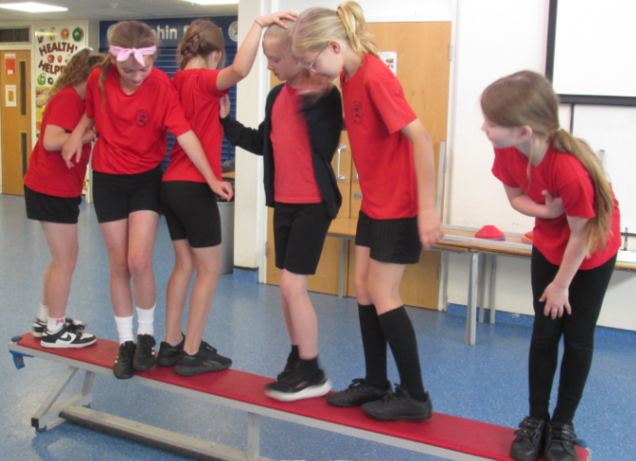

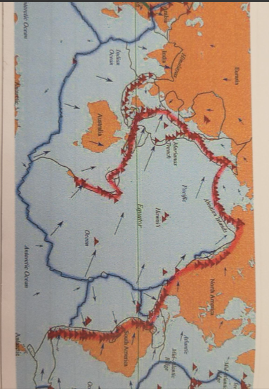
Year 6
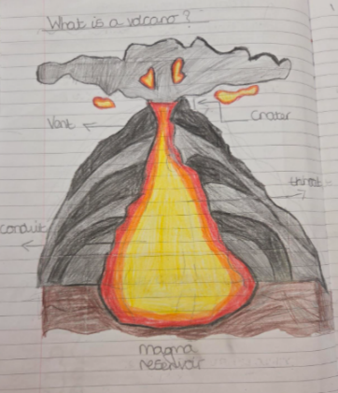
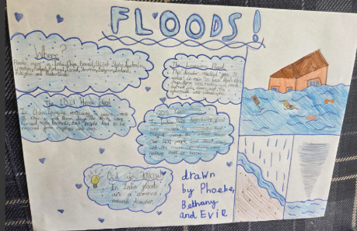

Year 6 have been studying natural disasters in geography. They have been learning about the causes of these disasters and how and where they occur.

Mini marathon
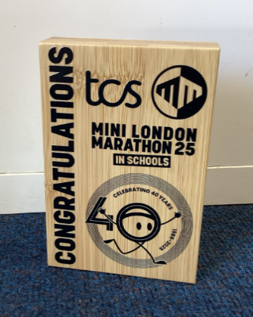
An update on the mini marathon that years 1-5 completed in April of this year. As so many children took part, we have been sent a lovely trophy to commemorate the achievement.


PTA events
If any parents would be interested in helping at this year’s fete, please email the PTA on Info@friendsofcannhall.co.uk


Bouncy castle wrist bands and game stall tokens can be pre ordered at Pta-events.co.uk/foch
Wrist bands are £5 and tokens can be preordered in lots of £5. The pre sale will be available until the 20th June and the tokens/wristbands will be delivered to classes by the Wednesday before the fete. Both will be available to buy on the day at the fete.

Children can wear non-school uniform this day for a 50p donation and can be collected from 2:00pm to visit the fete.

Year 6 Leavers’ Party Fundraising

The Year 6 fund raising is going well. The much anticipated ‘Soak the Teacher’ will be running during the summer fair, with all proceeds from this event going towards the Year Leavers’ party. We will accept card or cash payments.

Class photos
A reminder that it is class photos next week (Tuesday 17th June)
Please ensure children are wearing the correct uniform (unless pre-arranged) and looking their smartest. If the football and netball teams can bring in their kits on this day as well so they can have team photos taken. Thank you.

Father’s Day Messages


Reception, Year 2 and Year 5 have written Father’s Day messages to their dads and other special males in their lives that will be published in the Gazette today (Friday 13th June) They wrote some lovely words – we hope you enjoy reading them!

Thank a teacher day

Don’t forget that on Wednesday 18 June it is ‘Thank a Teacher Day’ - a special opportunity to recognise the extraordinary difference staff make to students every single day.

This day is about appreciating the hard work staff do to help create an impact to children and young people across schools, and colleges. The work they all do is vital to opening opportunities for children and young people.

To show your appreciation for those who make a difference in education every day, from teaching assistants to teachers to school leaders, every educator deserves recognition for their dedication and impact.

You can send a free personalised e-card to express your gratitude. It's a simple way to make someone's day and acknowledge the vital work happening in education across the country.

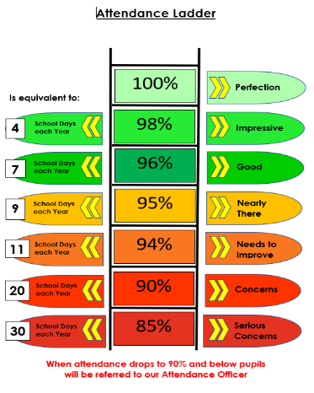
Attendance Update
Our overall attendance this week was 94.5%.
Please be aware that we
As always, if you are struggling with anything regarding your child’s attendance, please do not hesitate to ask to speak to somebody. We are here to help and want your child to get the most out of their education, whilst here with us and being in school every day, when they are well enough to do so, will help with this.

Prize Draw - Parent Survey

If you haven’t yet completed our short parent survey and want your views to play a vital role in shaping the future of our school, please, please, please take a few minutes to do so, using this link https://forms.office.com/e/YPFgjrr7e7.
We are already putting your feedback to good use, by using it develop positive change for the coming academic year.
Don’t forget, on completion of this survey, your name will go into a prize draw to win a £25 Tesco voucher. This survey will being closing next week. Thank you.

Celebration Assembly!

Well done to all the children who received certificates this week, to acknowledge effort and achievement.

EYFS: Jack and Cillian
Year 1: All the children
Year 2: Albie and james
Year 3: Jim and Emilia
Year 4: All the children
Year 5: All of 5S and Imogen
Year 6: Josh and Thomas



Uniform supplier

Don’t forget, from the Monday 30thJune, you will be able to order online from Anglia Sports and School Wear Ltd. Smarty-pants have confirmed that all orders up to the Monday 30th June will be honoured, to help clear their remaining stock.

Anglia Sports and School Wear are a local company, whose cost is also better - £5 cheaper on some items - and collection will be quicker as they are based behind The Range, so you won't need to wait for a 'once a month' school delivery.

Upcoming dates for your diary

16.06.25: KS1 SATs week
17.06.25: Class photos
25.06.25: Whole School Transition Day
27.06.025: PTA Summer Fayre (children can be collected from 2pm to visit the Fayre. Children can also wear non-school uniform for a 50p donation)
02.07.25: EYFS Sports Day
03.07.25: KS1 and KS2 Sports Day
06.07.25-09.07.25: Year 6 Residential Trip
09.07.25: End of Year Reports sent home (Y6 reports tbc)
10.07.25: Final Parents’ Evening/Meet Your New Teacher Evening (3.30-4.30pm)
11.07.25: Y6 Production to the rest of the school (dress rehearsal)
14.07.25: Y6 Production 9.30am and 5.30pm
15.07.25: Year 6 Production 5.30pm
17.07.25: Year 6 Leavers’ Party 4-6pm
18.07.25: Year 6 Leavers’ Assembly (10am)
18.07.25: Last day of term

From everyone here, have a lovely weekend and especially to all the important male figures in your lives – Happy Fathers’ Day for Sunday!

Kindest regards


Wendy Byrne

Other community events

Year 4 and 5 pupils

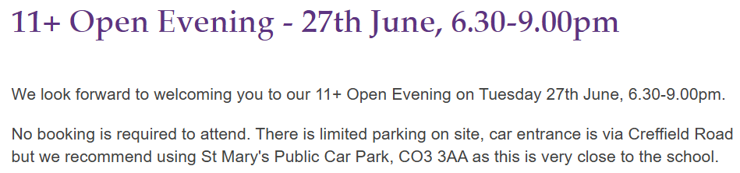


A fantastic opportunity for the budding young female footballers. We would love to be able to help them realise their dream.


Saturday 14th June
We’re pleased to share an exciting opportunity from Essex Tennis, supported by the LTA (Lawn Tennis Association).
They are running FREE Talent ID Day sessions across the County during May, June and July, aimed at enthusiastic children born in 2019 or 2020.
These are fun, friendly taster sessions designed to introduce children to tennis through games, movement, and play — no experience necessary and all equipment is provided.
Sessions run across various dates in May, June and July
Held at multiple venues across Essex
Free of charge
No equipment or experience needed
If you think your child might enjoy trying tennis, this is a fantastic opportunity to get involved.
Book a free place using the link below:
https://forms.office.com/e/8LfK89BZg8?origin=lprLink
Places are limited, so early booking is recommended.

